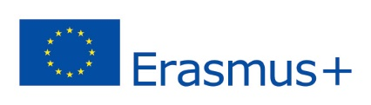

Evangelical Theological Seminary in Osijek
ERASMUS + PROGRAM - KA1
Teaching staff mobility in the academic year 2022/2023
Call deadline: 15. 09. 2022.

APLICATION FORM FOR THE APPROVAL OF ADDITIONAL FUNDING FOR TEACHING STAFF WITH DISABILITIES and/or SPECIAL NEEDS

Name and surname

Job title / function
Name of the host institution abroad for the implementation of Erasmus+ mobility
Duration of mobility
Type of disability / Type of special needs
Degree of disability (in %)
* in the attachment of this form, attach a document stating the degree of disability or confirming the diagnosis of a special need
Explanation of special needs

*Attachment (medical documentation)

Date:
Signature:

